world

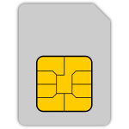 debit

1234 4567 7890 0123

VALID THRU

12/23

Lee M. Cardholder Mastercard